EXPERIMENT- 7

Experiment with different layouts and color schemes for an app. Collect user feedback on aesthetics and usability using GIMP(GNU Image Manipulation Program (GIMP)

NAME: GAYATHRI JAYAM S REG NO: 240701142

AIM:
The aim is to trial different app layouts and color schemes and evaluate user feedback on aesthetics and usability using GIMP.

PROCEDURE:
Step 1: Install GIMP
- Download and install from the official website.

Step2: Create a New Project
- Open GIMP
- Canvas Size: 1080 × 1920 pixels (standard mobile screen)

Step 3: Base Layout Design
- Divide Sections:
  - Use Rectangle Select Tool to define Header ,Content Area, and Footer.
  - Fill using Bucket Fill Tool with base colors.

Add UI Elements:
  - Text Tool :For headings ,button texts, and labels.
  - Shape Tools :For buttons, input fields ,image placeholders.

Layer Organization:
  - Assign each UI component to a separate named layer:
    - Example: Header, Button Login , Text Title ,Input Field Email

Step4:Create Color Variants
- Duplicate Layouts:
  - Right-click on the project tab >Duplicate.
    - Edit each with different colour schemes using Colorize Tool or Bucket Fill.

Save Layouts:
  - File > Export As:
- Layout1.png
- Layout2.png

Layout3.png Step5:Collecting User Feedback Google Form Link:
- https://docs.google.com/forms/d/e/1FAIpQLSfft1LNZkRSObjgzm-_zEo3n7ovQU5fqyHXZputEpfZM4OJkw/viewform

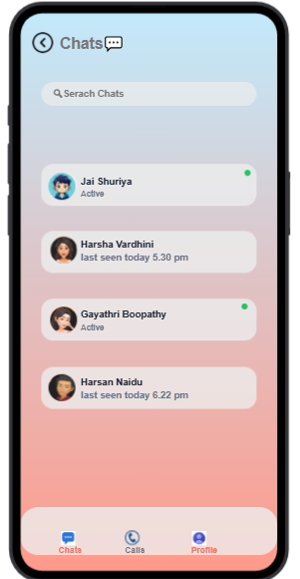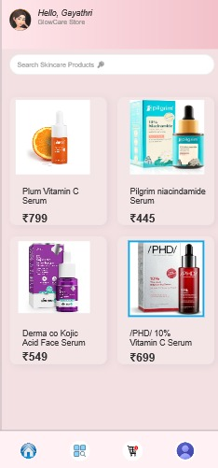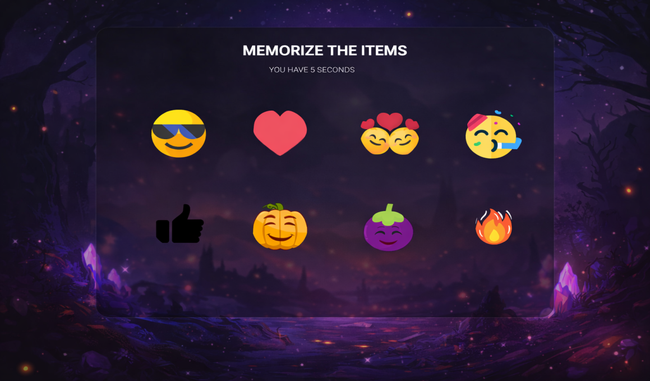

Procedure:
- Shared all three layout images with users.
- Asked users to rate based on:
  - Visual appeal
  - Usability
  - Readability
  - Colour preference

User Feedback:
Layout 1:
- Simple layout with bold header and minimal UI •
Improve colour contrast
- Add button styling (e.g., shadow or depth)

Layout 2:
- Improved hierarchy with vibrant colour palette
- Slightly cluttered background, tight spacing
- Increase spacing between sections

Layout 3:
- Clean, minimal, professional layout with consistent spacing •
Keep design as-is
- Possibly apply theme customization options in final product

Final Recommendation Preferred Layout: Layout3
Why?
- Clean and modern look
- Excellent usability
- Balanced colour scheme
- High user satisfaction in both function and form

Step 6: Iterate and Refine
- Refine the Design:
  - Based on the feedback, make necessary adjustments to the layout and color scheme. •

Experiment with additional variations if needed.
- Final Testing:
  - Conductafinalroundoftestingwiththerefineddesigntoensureusabilityand aesthetic satisfaction.

